Attribute

The attribute is used to describe the property of an entity. Eclipse is used to represent an attribute.

**For example,** id, age, contact number, name, etc. can be attributes of a student.

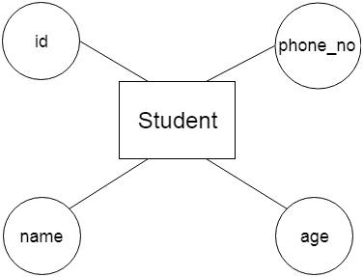

**a. Key Attribute**

The key attribute is used to represent the main characteristics of an entity. It represents a primary key. The key attribute is represented by an ellipse with the text underlined.

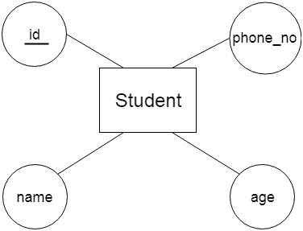

**b. Composite Attribute**

An attribute that composed of many other attributes is known as a composite attribute. The composite attribute is represented by an ellipse, and those ellipses are connected with an ellipse.

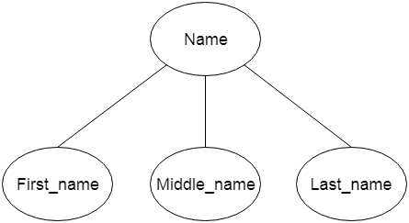

**c. Multivalued Attribute**

An attribute can have more than one value. These attributes are known as a multivalued attribute. The double oval is used to represent multivalued attribute.

**For example,** a student can have more than one phone number.

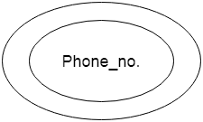

**d. Derived Attribute**

An attribute that can be derived from other attribute is known as a derived attribute. It can be represented by a dashed ellipse.

**For example,** A person's age changes over time and can be derived from another attribute like Date of birth.

